Big document of diligence questions (technical)

Missing Questions:
How does RLT fit in the competitive landscape of other modalities?

Target Selection

What is the minimum copy number required for a good RLT target?
We selected targets with IHC H-scores of 200–300, expressed in greater than 60% of tumor cells — a bar set deliberately above PSMA, one of the most clinically validated RLT targets in oncology, which has up to 200,000 copies per cell and an H-score of 150–200.
That said, a single minimum copy number cannot be applied universally, because the biology of the target is just as important as the absolute expression level. Key factors include whether the target is membrane-localized, whether it internalizes, and if so, whether it is degraded or recycled — and at what rate. Expression homogeneity within the tumor matters equally: a high copy number present on only a small subset of cells will limit therapeutic efficacy regardless of the absolute level.
Because copy number data are rarely available for novel targets, we infer expression levels from direct protein quantification and cellular localization using IHC data, calibrated against three well-characterized RLT targets with known receptor copy numbers and established IHC profiles: PSMA, SSTR2, and DLL3:

Target | Copy number | H-Score
Sego Targets | NA | >200
PSMA | 200,000 | 150 to 200
SSTT2 | 50,000 | 100 to 150
DLL3 | 6,000 | 10 to 50

Isotope Selection
How are you thinking about the half-life mismatch between short peptide clearance (hours) and longer-lived isotopes like 225Ac or 161Tb (may overlap with KLK2 question below)?
ANSWER:
We are not trying to pair isotope/serum half-life. The two approved RLT agents (Lutathera and Pluvicto) do not have paired isotope/serum half-life. We effectively have the same format (peptides/small molecules) and isotope half-life (7-10 days) to deliver RLTs that are approvable.
Beyond format and isotope selection, approvability lies in target selection and medicinal chemistry to optimize pk properties. Sego targets have been selected with a specific expression profile we believe is suited to RLT (i.e. highly expressed in the tumor and minimal expression or accessibility in healthy tissue). The goal is to maximize the radiation dose to the tumor (AUC). We achieve this by using med chem optimization which is directed at two complementary objectives:
high-affinity, rapid tumor uptake and internalization akin to first-pass capture given the receptor density on target tumors, with sufficient circulation time to reach intratumoral Cmax; and
rapid renal clearance into the bladder thereafter, with minimal kidney retention to protect the expected dose-limiting organ. Once the peptide has delivered the isotope intracellularly, the long physical half-life of 225Ac or 161Tb becomes an asset rather than a liability. It extends the cumulative tumor dose over days while the targeting vector itself has long since cleared the systemic circulation.
What do we know about tumor types best suited for 161Tb targeting?
ANSWER:
161Tb is well suited to tumor types presenting with mixed disease burden from bulky primary lesions and macrometastases through micrometastases and circulating tumor cells (CTCs). Its beta emission (comparable to 177Lu) drives crossfire-mediated debulking of large tumors, while its Auger emission delivers the short-range, densely ionizing damage needed to kill single CTCs and sub-millimeter micromets. We see 225Ac as our primary RLT isotope but there may be an on target/off tumor expression profile and mixed disease burden profile in a particular tumor type/indication that lends itself better to 161Tb from an efficacy and safety profile perspective.
Why do you speculate 161Tb hasn’t been studied clinically to the extent that either 177Lu, 225Ac or 212Pb has?
ANSWER:
Historically, it has not been studied clinically due to lack of availability of cGMP isotope. In the last year this has been resolved with multiple suppliers of cGMP 161Tb (see list of suppliers in answer below), with the expected filing of US DMFs and the community working on draft USP/Ph.Eur. monographs. Furthermore, Nusano intends to supply cGMP 161Tb.
Can you walks us through the starting material for 161Tb production, relative abundance and methods for manufacturing 161Tb?
ANSWER:
The critical starting material is highly enriched 160Gd (typically >98% enrichment vs. ~21.9% natural abundance). The process is almost identical to the production of 177Lu, which is well established. This is the principal supply-chain consideration: enriched stable isotope production is concentrated among a small number of global supplier which is historically dominated by Russia (Electrochimpribor / Rosatom), with ORNL in the US and a few European producers as alternatives. Geopolitical exposure to Russian supply has driven renewed Western investment in domestic enrichment capacity (DOE Isotope Program, URENCO, and others). We have a strategy developed for short-term (R&D/Clinical Trial needs) and long-term (commercial needs) supply chain.
The University of Utah (23 minutes away) have published heavily on production of 161Tb and are able to supply us with research quantities from their trigger reactor. Our strategic relationship with Nusano, the isotope supplier adjacent to our facility, strengthens this model by providing secure access to 225Ac and 161Tb, enabling shorter development cycles.
What is your chelator strategy (off-the-shelf vs proprietary)? How do you think about chelation chemistry when switching isotopes?
ANSWER:
We plan to use off-the-shelf DOTA/DOTAGA derivatives as they have stability for the radionuclides we will utilize in our clinical development, including 68Ga, 177Lu, 161Tb, and 225Ac. In order to reduce complexity of pairing isotope to chelator for imaging and therapy phases of clinical development in a manufacturing and potential PK impact standpoint, a single, robust multi-radionuclide chelator is our path forward.

CLDN1

Can you elaborate on the binder design? What epitope is your cyclic peptide designed to target? Is the target recognized only in non-junctional CLDN1? Is this the same epitope as that targeted by the Alentis Therapeutics mAb?

Can you elaborate on the binder design?
We will generate monocyclic peptides against CLDN1 these will further med chem optimize using the whole RLT molecule (i.e. with the linker chelator and metal bound)

What epitope is your cyclic peptide designed to target?

We will select a number of CLDN1 binders that bind either to the ECL1 or ECL2 extracellular loop regions.

Is the target recognized only in non-junctional CLDN1?

The selected CLDN1 binders only bind to non-functional CLDN1 in cancer. only recognize non-junctional CLDN1in tumors..

Is this the same epitope as that targeted by the Alentis Therapeutics mAb?

Our preference would be only to move forward CLDN1 binders that do not bind the same epitope as the mAb from Alentis Therapeutics. However, as a bench marking exercise, we perform head-to-head comparison with a binder that binds to the same epitope as Alentis mAb. The dosimetry of the RLT binders will then be compared head-to-head in mouse xenograft models, and the peptides with favorable tumor absorbed dose (uptake that is retained in the tumor) to organ at risk dose (uptake that has minimal retention in the organ at risk) will be selected.

Compared with the Alentis anti-CLDN1 mAb approach, what are the pros and cons of a cyclic peptide targeting the CLDN1 ECL regions? Can you comment on the following two aspects (1) Specificity of CLDN1 expression in normal tissues vs tumor cells (2) Compared with mAbs, the pros and cons of a cyclic peptide vs antibody in the context of radioisotope-targeted therapy targeting CLDN1.

We believe peptides are the right modality for RLT, providing the best balance of high target affinity, tumor uptake, rapid clearance and delivery at non-saturating mass doses (as compared with antibodies).

Antibodies provide high affinity, specificity, and bivalency, but the prolonged exposure associated with antibodies can result in sustained antibody-mediated payload delivery to normal tissues, which is suboptimal for radionuclide delivery. Additionally, the ADC’s antibody can interact with Fc-gamma receptors, leading to hematologic toxicity, which is the most frequent off-target dose-limiting toxicity, irrespective of the expression profile of the target.

In contrast, cyclic peptides offer similar affinity and specificity as antibodies, faster tumor penetration, lower nonspecific exposure, no Fc-gamma interaction, shorter circulation half‑life, and non‑saturating dosing—all advantageous for improving tumor‑to‑normal dose ratios. The rapid blood clearance and sub-saturating doses of a peptide RLT can minimize cumulative off-tumor exposure, which is a problem for antibodies dosed at saturating conditions and with long blood exposure (T_{1/2} of days to weeks), combined with natural CLDN1 recycling/turnover (transient exposure of CLDN1 in healthy tissues). For RLT, these PK properties generally translate to a higher therapeutic index while maintaining sufficient target engagement.

In healthy tissues with high CLDN1 expression, how do you think about target-related risk?

We evaluate risk based on target accessibility rather than absolute expression. In healthy tissues with high CLDN1 levels, CLDN1 is predominantly junctional and shielded from circulating ligands. Peptide RLT kinetics are strongly a first-pass, and can be thought of as “snapshot” in time for exposure, with rapid clearance and typically non-saturating mass dose, while ADCs are a long-circulating “video” that repeatedly samples antigen for days, often above saturation, increasing the probability of sustained normal-tissue payload delivery. In addition, high tumor CLDN1 expression acts as a beneficial tumor sink for circulating drug, and rapid clearance of cyclic peptides further reduces sustained exposure in normal tissues. RLT has the added advantage that we can use the same peptide for image-based patient selection and early dosimetry, providing an additional safeguard to identify any unexpected uptake prior to therapeutic dosing.

Can you compare CLDN1-targeted ADC vs RLT approaches in squamous lung cancer, HNSCC, HCC, and CRC? Can you provide clinical evidence of radiosensitivity in these indications?

RLT will be particularly attractive in metastatic or micrometastatic disease, where uniform ADC delivery to every lesion and every cell is difficult to achieve due to multiple factors, including antibody penetrance and antigen heterogeneity. ADC efficacy depends on tissue penetration, antigen engagement, internalization, and intracellular payload release. Peptide RLT delivers radiation dose when the ligand localizes to the tumor with or without internalization, e.g. with beta emitters, crossfire can treat neighboring cells and is less dependent on uniform intracellular trafficking.
From a radiosensitivity standpoint, these indications all have meaningful clinical precedent for radiation response, but they are not identical: lung squamous and HNSCC are classically radiotherapy-responsive (radiation is foundational with curative intent). HCC can respond well to radiotherapy, though treatment is often constrained by normal liver tolerance, as HCC patients usually present with liver comorbidities. Radiosensitivity in CRC is context-dependent and considered more dose demanding, but many patients do respond well to radiotherapy. Radiation (SBRT) is highly effective in rectal cancer and oligometastatic settings, but durable control often requires a higher effective dose. High CLDN1 expression and radiosensitivity were the main factors in selecting lung squamous as our lead indication.

CEACAM5

Based on past clinical experience with ADCs, T-cell engagers, and CAR-T therapies, what gives you confidence that CEACAM-5 remains an attractive target in CRC?

Extensive human imaging experience supports target accessibility and de‑risks translation. Historical programs were limited primarily by modality constraints, which will not apply to a CEACAM5 targeted peptide RLT. ADCs suffered from slow internalization and payload class adverse events (e.g. ocular tox) that resulted in a narrow therapeutic window (ESMO 2022). CAR-T studies reported various grades of immune‑mediated toxicities, with one specific trial reporting on-target off-tumor severe colitis after intraperitoneal administration (Med Onc 2025). T-cell engagers reported GI issues as on-target, off-tumor adverse events that occurred early after dosing and at higher doses (Nat Comm 2023). CEACAM5 remains very highly and homogeneously expressed in CRC, with tumor‑specific accessibility due to loss of apical polarity and overexpression in cancer cells. RLT is not dependent on the appropriate tumor-immune microenvironment or rapid internalization and therefore better aligns with CEACAM5 biology.

Can you provide additional color on the clinical development plan of M9140 from Merck KGaA? What strategic considerations led to the decision to partner in earlier lines of therapy?

Note: we assume you mean positioning in earlier lines of therapy here, vs. BD-type partnering

Development of M9140 underscores confidence in the target and illustrates the operational complexity of advanced biologics. M9140 (Precemtabart tocentecan) is currently positioned as a potential third-line treatment (for heavily pretreated patients with irinotecan-refractory mCRC). Its Phase I ORR of 31% compares favorably to current 3L+ SOC monotherapies, which typically yield ORRs of 1-2%. Based on positive Phase I results (PROCEADE-CRC01), Merck plans to advance the drug directly into Phase III (initiate in the first half of 2026). Merck also launched a basket trial (Phase Ib/II, 2025) to evaluate M9140 monotherapy in other CEACAM5-high tumors (gastric, NSCLC, pancreatic cancers).

Merck’s strategy to move into earlier lines is based on several key factors: 1) the superior safety profile, due to a b-glucuronide cleavable, hydrophilic linker that is stable in circulation and cleaved in the lysosome (intracellular) and the tumor interstitium (extracellular), with no IDL or ocular toxicities to date, and primarily hematologic toxicities that are manageable and reversible, 2) the potent payload (topoisomerase 1 inhibitor exatecan) and high drug-to-mAb ratio might overcome irinotecan resistance. This makes M9140 a viable candidate for long-term combination therapies in earlier settings where patients are less frail.

That rationale for earlier positioning would also apply to RLT, which will be designed to deliver minimal on-target, off-tumor toxicity due to its optimized PK. Anti-CEACAM5 RLT exhibits anti-tumor activity upon internalization and both crossfire and bystander effects when bound to the cell surface (choice of radionuclide). RLT would provide an alternative treatment option to avoid or overcome irinotecan resistance (another TOP1 inhibitor). Early‑line positioning aims to maximize benefit in lower‑burden disease. This reinforces our view that modality choice and disease setting materially affect CEACAM5 outcomes and that simpler, scalable peptide‑RLT approaches can offer executional advantages. We see RLT as a modality with high combinability due to its orthogonal mechanism of action.

From a safety perspective, while ADC toxicity profiles are generally manageable, prior T cell therapy experiences have shown toxicities including colitis and respiratory toxicity that may be target-related. Can you share your thoughts on the potential on-target toxicity of CEACAM-5 and your approach to mitigating these risks?

Toxicities observed with other CEACAM5-targeting therapies are thought to be modality-driven, rather than target driven: immune activation in T-cell therapies (in the lung) and payload metabolism in ADCs. RLT as a modality has fewer associated toxicities; instead, many RLT observed toxicities originate from on-target, off-tumor binding.

Based on clinical studies with other modalities, we do not expect significant on-target, off-tumor toxicities from CEACAM5 expression in healthy epithelial tissues. CEACAM5 expression on the apical surface of the GI epithelium is less accessible to RLT than CEACAM5 in the tumor, and rapid clearance from the blood circulation further improves the therapeutic index. Clinical imaging studies using antibodies or smaller nanobodies confirmed minimal uptake in the normal colon, attributable to preserved apical localization. Regardless, we will closely monitor uptake in the gastrointestinal tract and lung using FIH imaging studies. The advantage of using the same peptide for imaging-based dosimetry is central to our safety strategy and will guide patient selection and dose escalation.

Can you compare the targeted domain of the anti-CEA M5A used in the PET bioimaging study you showed in the slide with the epitope targeted by the NIH CEACAM-5 TCR-T? Can you elaborate on the biological rationale of the M5A antibody from bioimaging study does not recognize normal colon mucosa?

The M5A antibody binds within the membrane-proximal IgC-like domains A3-B3 of CEACAM5, which is accessible on tumor cells but not in the normal healthy colon (expression restricted to the apical membrane). The clinical imaging data with ⁶⁴Cu-M5A support the concept that CEACAM5 can be selectively targeted when polarity is lost in tumors (Wong et al, 2023).

In contrast, TCR-based approaches recognize intracellularly processed CEACAM5 peptides presented by HLA on the cell surface. This processing and presentation of CEACAM5 peptides on HLA occurs on both healthy cells and tumor cells. HLA expression in colonic epithelium is not polarized to the luminal side like CEACAM5 and might contribute to the toxicity of NIH TCR-T. The specific peptide for the NIH CEACAM-5 TCR-T program is IMIGVLVGV (residues 691-699 of CEACAM5) expressed on HLA-A*02:01. These residues are located within the A3-B3 domain of intact CEACAM5. Unlike small molecules or peptides with rapid clearance, adoptive T-cell therapies demonstrate prolonged, unpredictable systemic persistence (weeks to months), allowing continued migration into and engagement with normal tissue compartments such as the intestinal mucosa, where basal CEACAM5 expression may trigger on-target, off-tumor toxicity. High-affinity TCRs used in CEACAM5 TCR-T trials have shown on-target, off-tumor toxicity, including severe inflammatory colitis (Parkhurst et al., 2011).

Using a cyclic peptide-targeted approach, can you discuss the risk of targeting normal epithelium compared with an antibody-based approach from the bioimaging study?

Cyclic peptides are smaller, clear more rapidly, are more likely to bind to targets in tumors where they are highly expressed and accessible and are administered at non-saturating mass doses compared with antibodies. This reduces prolonged exposure of normal epithelium and limits cumulative off-target radiation dose. As a result, peptide-based RLT is expected to further widen the therapeutic index relative to antibody-based approaches.

ACP3

We did not spend time on ACP3 previously. Can you walk us through the target, development at BMS, and positioning in mCRPC?
Note: We will schedule a follow-up call to discuss ACP3 as well as the 3 other prioritized targets in greater detail.
Target: ACP3 (prostatic acid phosphatase) is a long-validated prostate cancer antigen with expression maintained across disease stages, including PSMA-negative mCRPC, making it an ideal alternative to PSMA RLT. From a target expression, biology and feasibility perspective, ACP3 is (1) highly expressed in ~95% of PC patients across disease stages, (2) has transmembrane forms that are natively internalized and shed at low levels into the blood, and (3) has an active site that is amenable to small molecule and peptide targeting.

Development Landscape: BMS/RayzeBio are currently pursuing a small-molecule based RLT approach, which demonstrates the attractiveness of the target, but lacks internalization into cells – an opportunity for Sego. An early first in human study has shown strong tumor uptake and significantly reduced on-target, off-tumor uptake vs. PSMA RLT (SNMMI 2025 presentation). While early clinical data is promising, preclinical studies show OncoACP3 is not internalized into the cell, which may reduce its overall effectiveness in inducing lethal DNA damage to the cell when using isotopes such as Tb-161 which emit beta and auger electrons (Nat Biomed Eng 2025). We believe that an internalizing cyclic peptide RLT with a ²²⁵Ac or ¹⁶¹Tb payload may be more effective at tumor cell killing.

Positioning in mCPRC: The shortest path to the market is to demonstrate improved efficacy in the mCRPC with a superior safety profile (owing to no expression of ACP3 in the salivary gland and kidney) over PLUVICTO. We would also include PSMA-negative patients (~15% of the total of high risk PCa) in these studies. However, due to the better safety profile, it will move more rapidly than PLUVICTO into early lines of therapy. However, these trials, owing to the longer MFS and OS, will longer to read out and will need to start at risk once early signs of efficacy are confirmed.

Research
Can you describe your target discovery process/engine? Do you envision primarily using publicly available data for the foreseeable future or do you anticipate doing more proprietary data generation for target discovery?
Sego thorough target screening process evaluates targets based on a variety of criteria, including expression, biology, feasibility and landscape. Within these criteria we prioritize specific characteristics, including robust tumor expression on a protein level and limited total protein expression or accessibility in healthy tissue. We also factor in RLT competitive landscape and read through from non-RLT programs in the clinic.

We are building capabilities to validate targets in our facility. Key internal assays will be target expression and target biology features, such as tumor vs healthy tissue microarray data and target internalization/recycling, respectively.

With respect to target discovery, we believe that there is a wealth of novel, innovative targets that can be prosecuted. As of now, we are not developing novel target screening/identification platforms, such as spatial transcriptomics and subsequent IHC validation. We have identified and spoken to several companies in the target discovery space in the event we move beyond our list of 12 high priority targets.

Can you walk through hit finding and molecule optimization processes for cyclic peptides and peptide dimers? How long do you anticipate this taking? Can you describe hot and cold optimization in greater detail?
Novel hit finding will be accomplished via two overarching routes, (i) de novo mRNA, DEL, and phage, and (ii) structure-based design utilizing known ligands and crystal structures with concomitant FTO evaluation (as alluded to and discussed in the following question).

Step 1. Appropriate selection logic will be chosen to imbue obtained hit series with target specificities and affinities that are expected to derisk their further develop in cold hit-to-lead and lead optimization stages.

Step 2. Bespoke in vitro screening funnels tailored to each specific target will guide optimization of our macrocyclic peptide series. To enable quick DMTA turnaround and minimize time in cold optimization, we will rely on focused synthetic libraries numbering in the 0.1-10k members and affinity selection mass spectrometry (ASMS) workflows enabling generation of dense SAR in a short timeframe.

Step 3. A suite of complementary biophysical assays (SPR, ITC, DSF) will be used to corroborate ASMS data. Throughout the ligand affinity maturation process we will consistently generate exemplar ligand-linker-chelator conjugates to derisk ligand series as early and as quickly as possible. This will include evaluating cold-metal, including lanthanides, loaded conjugates in cell binding and cell internalization assays, in vitro ADME, and xenograft mouse PK (using MS and ICP-MS for BA), with the goal of pushing these into hot evaluation and optimization as fast possible. Tailoring the physical properties of our ligand libraries and conjugates to avoid being overly (i) cationic, (ii) lipophilic, or (ii) aromatic. This will ensure we work in a chemical space that predisposes our compounds to have fast renal clearance, high tumor uptake and retention, and high solubilities. Additional in vitro ADME assays we will monitor and optimize for are solubility, serum and blood stability, acid stability, mast cell degranulation, and periodic uptake/efflux transporter substrate testing. In summary, throughout the ligand affinity maturation process (of which there will be numerous series running in parallel), we will generate cold metal loaded conjugates and drive them through all cold evaluation assays to hot optimization as fast as possible to obtain a go/no-go decision on each series as fast as possible.

Regarding dimerization, we plan to consider target multimerization and linker attachment vectors from our full conjugates to guide the design of dimers, including homo-, hetero-, and biparatopic-dimers, that have appropriate spatial arrangement to exploit those factors. We will leverage x-ray crystallographic data gathered throughout preclinical development to guide this. This will be an ongoing optimization push throughout cold optimization.

In terms of hot optimization and evaluation, we plan to test several lead compounds from chemically distinct series that bind different target epitopes to identify those that have the best cellular internalization/retention, PK, and efficacy.

Step1. Initial assays (radiolabeling, cell binding, cellular internalization) cell will focus on recapitulating and confirming cold-metal loaded studies.
Step 2. We will look at cell killing, serum stability, and stability in formulation buffer. At this point we will have an efficacy ranking (albeit in vitro) and stability assessment which will allow us to further prioritize sets of compounds for mouse dosimetry.
Step 3. We will understand compound differences in terms of both healthy tissue and tumor uptake and retention. While murine dosimetry is a poor predictor of human PK, it can be used to identify those compounds with differentiated biodistribution that warrant further evaluation in humans. We will take several compounds from distinct chemical series that have differentiated murine dosimetry into FIH phase 0 clinical studies to gain an understanding of our compounds’ human PK and thereby enable development candidate choice.

Peptide and small molecule binders exist for a portion of the 40 identified targets - could any of this molecular matter be used to accelerate development?
As above, this is one of our two general approaches to hit finding. An important aspect of this is simultaneous FTO evaluation of all devised chemical approaches and will be an integral part of our process. In terms of specific routes forward, we will leverage known binding interactions (from x-ray structures), in conjunction with understood synthesizability constraints, to design bespoke focused libraries. We expect these focused libraries to range in the 0.1 – 10k member size. While they are smaller in number than the true de novo approaches above, the targeting of chemical space around known interactions minimizes the risk of not generating novel hits. Chemical series identified from these libraries will then be triaged and evaluated in much the same manner as described above. We expect hit finding here to take 3-4 months.

When you move to in vivo, can you talk about some of the TPP/characteristics you will be looking out for? Are there specific biodistribution, tox parameters that you’d see as red/green lights?
Preclinical imaging provides a critical stage gate for candidate selection and dosimetry studies will form the basis of pharmacology reports for IND submission. Below are imaging/PK characteristics we look at to funnel compounds to clinical translation.
- Blood clearance. If a radiotracer clears from blood too fast, then there is insufficient antigen exposure for effective tumor uptake. In contrast, long circulating half-life could lead to increased marrow exposure and potential hematological toxicity.
- Tumor-specific uptake. Specificity to antigen positive vs antigen negative tumors and/or blocking studies demonstrate antigen specificity.
- Tumor retention. Retention of radioactivity over a period of ~1 week is indicative high tumor absorbed dose.
- Anomalous healthy tissue uptake. Indicative to potential lack of specificity or radiometabolites accumulating in healthy tissues. Tissue of highest concern would be non-specific marrow uptake and retention.
- Hepatobiliary clearance. Gallbladder and liver uptake is not indicative of classical peptide clearance and is a red flag for improper physiochemical properties, such as hydrophobicity and lipophilicity. Additionally, it could indicate the presence of unwanted radiometabolites.
- Renal clearance. Kidney uptake and retention of peptides in RLT is of utmost importance due to the inherent renal clearance of peptides and potential of kidneys being the healthy organ at risk from a dosimetry perspective. However, preclinical kidney uptake and retention of radiolabeled peptides have not been predictive of clinical kidney uptake and retention. Sego has identified examples in which preclinical imaging demonstrating low total uptake and rapid kidney clearance of radioactivity has not been translated into humans. The opposite has also been identified – high uptake and slow clearance of kidney radioactivity in mice has translated to much lower overall uptake and faster clearance in humans. Due to this, Sego has developed a clinical development strategy which would allow broad go/no-go criteria regarding preclinical kidney uptake and retention. Sego will develop 3-5 candidates per program in FIH Phase 0 human imaging studies and allow the clinical PK and dosimetry to select our lead compound for Phase I/II therapeutic trials.

Are there any dose-limiting organ ratios that you need to meet for an asset to move into later stage clinical trials?
Sego applies rigorous, quantitative, go/no-go thresholds to advance only assets with a compelling therapeutic index. Specifically, Sego requires:
- Tumor-to-kidney absorbed dose ratio greater than 3
- Tumor-to-red marrow absorbed dose ratio greater than 20

These thresholds reflect lessons learned from approved RLT products and external beam critical organ dose limits. Lutathera and Pluvicto have demonstrated red marrow toxicity through distinct mechanisms; direct on-target marrow irradiation in the case of Lutathera, and crossfire irradiation from bone metastases combined with blood-pool dose in the case of Pluvicto. Our first six targets have no known red marrow expression. Our approach to Medicinal Chemistry ensures pharmacokinetic engineering further reduces risk by driving rapid tumor uptake and retention while promoting fast clearance from the blood pool.

In addition to the ratio, we have also set clinical dosimetry targets. These are designed to maximize tumor kill, while protecting critical organs within well-established radiation doses:
- Tumor: >100 Gy cumulative dose
- Kidney: ≤23 Gy cumulative dose
- Red marrow: ≤2 Gy cumulative dose

These thresholds are aligned with the FDA's August 2025 draft guidance on RLT dose optimization. This is a regulatory tailwind that Sego is positioned to leverage through early dialogue with the agency to shape its trial design.

Rather than committing to a full therapeutic program on a single candidate, Sego's Phase 0 imaging PK/dosimetry study is designed to screen multiple candidates and generate quantitative biodistribution and dosimetry data before significant capital is deployed. This study will flag any unexpected off-target organ exposure not observed in preclinical models, using established EBRT radiation tolerance limits as guardrails. The output is a formal Go/No-Go decision at the earliest possible stage — selecting the candidate with the widest therapeutic index and highest probability of clinical and commercial success.

Pursuing polarized or shielded antigens are intriguing. Can you review any learnings from targeting PSMA in prostate cancer as this is also a polarized target from our understanding? What was the ratio of RLT binding off tumor but on target prostate cells that have maintained their polarity? Are there concerns about inflammation or other processing breaking polarity and causing toxicity?

Yes, PSMA is a polarized target with apical expression in the prostate, kidney and salivary glands. PSMA (glutamate carboxypeptidase II) is a kidney brush border enzyme expressed in the lumen of the proximal tubules. Due to the physiology of the kidney and renal filtration cutoff, small molecule PSMA-targeted agents such as PSMA-617, PSMA-11 and PyL, have access to the lumen of the proximal tubules and show target-specific uptake in the kidney. Due to this and Sego’s use of smaller targeting molecules that would have access to the lumen of proximal tubules via physiological clearance, we have avoided targets in which there was target protein expression in the kidney proximal tubules.

PSMA is expressed on the apical lumen of the acinar epithelium of salivary glands, a tissue that is sensitive to ionizing radiation with a poor regenerative capacity. The mechanism of PSMA uptake in the salivary glands complex; postulated to be a combination of both target-specific uptake and nonspecific uptake and retention, such as interacting with glutamate carboxypeptidase III. The significant, intense uptake in the salivary glands is not fully explained by the low physiological expression of PSMA. Salivary glands are highly vascularized and have an excretory function. Acinar cells allow fluid to enter the salivary glands, and it is via this mechanism that PSMA targeted agents can have target specific uptake in salivary glands.

The healthy prostate has negligible PSMA radioligand uptake, demonstrating that the apical expression of PSMA in the healthy prostate is in fact shielded from systemic RLT targeting. However, benign prostatic hyperplasia and prostatitis can show mild PSMA uptake, which can complicate radiographical interpretation of the scan. Importantly, it is the over expression of PSMA in prostate cancer lesions compared to healthy/benign prostate that greatly increases the uptake of PSMA radioligands. Due to this Sego has selected targets in which there is a robust over expression of target density on cancerous cells compared to healthy tissues. However, in the context of inflammation and target accessibility, we have acknowledged the potential that non-cancerous, inflamed tissue might have altered polarization and reduce the tumor-specific accessibility. Comorbidities such as IBD or severe asthma are indications to look out for.

Other advisors to us have described the process of RLT discovery as highly empirical. How will you systematically evaluate RLT molecules / make it less of a guessing game?
Not all of RLT discovery is empirical — we systematically evaluate the physical and biological characteristics we know predict human performance. For any candidate, we apply strict go/no-go criteria upfront: we won't advance a binder with affinity greater than 10 nM, nor one that is highly charged, excessively lipophilic, or fails to kill target-positive cancer cells in a specific, dose-dependent manner in vitro. These parameters are well-established determinants of peptide pharmacokinetics in humans and give us a rigorous, evidence-based filter early in the discovery process.
Where the empiricism does creep in is the translation of mouse dosimetry to humans As with virtually every other therapeutic modality in oncology, rodent models are poor predictors of human pharmacokinetics and biodistribution.
What sets RLT apart, however, is a powerful tool to bridge that gap: Phase 0 microdosing studies. By administering an imaging dose of the therapeutic radioisotope directly in humans, we can measure actual human dosimetry early, rapidly, at lower regulatory burden, and at a fraction of the cost of a full Phase I. This means we're not extrapolating from mouse data and hoping for the best — we're generating direct human evidence before committing to a full clinical therapeutic program. It's one of the most compelling and underappreciated advantages of the RLT modality, and it fundamentally changes the risk profile of our development decisions.

Can you walk us through your strategy for choosing cyclic peptides as your platform over various other modalities, including small molecules, antibody-based approaches, and other alternatives you considered?

Cyclic peptides exhibit the ideal balance of high specificity and target affinity, driving high tumor uptake with a relatively short biological half-life (~10s of minutes), thereby allowing for 1st pass kinetics to restrict off-tumor binding. Further, cyclic peptides can be engineered for internalization, rapid clearance, and reduced kidney retention, which are critical parameters for radioligand therapy without compromising tumor uptake. In contrast, full length antibodies can cause bone marrow toxicity due to their long serum half-life, while small antibody fragments and small proteins suffer from high kidney retention which cannot be engineered out without compromising tumor uptake. Furthermore, the timeline for developing, manufacturing, and gaining regulatory approval of biologics is longer and more expensive. Small molecules are appealing for their tunable pharmacokinetic properties but are best suited for targets with clear binding pockets or enzymatic sites. Case in point: approved PSMA- and SSTR2-RLTs were generated from known inhibitors and natural ligands. However, not every target has an active site or clear pocket for small-molecule binding, thus limiting target selection and encouraging the use of more diverse modalities, including peptides. Furthermore, small molecules may have lower affinities or higher Koff rates, making tumor retention more difficult, especially given their generally more rapid clearance.

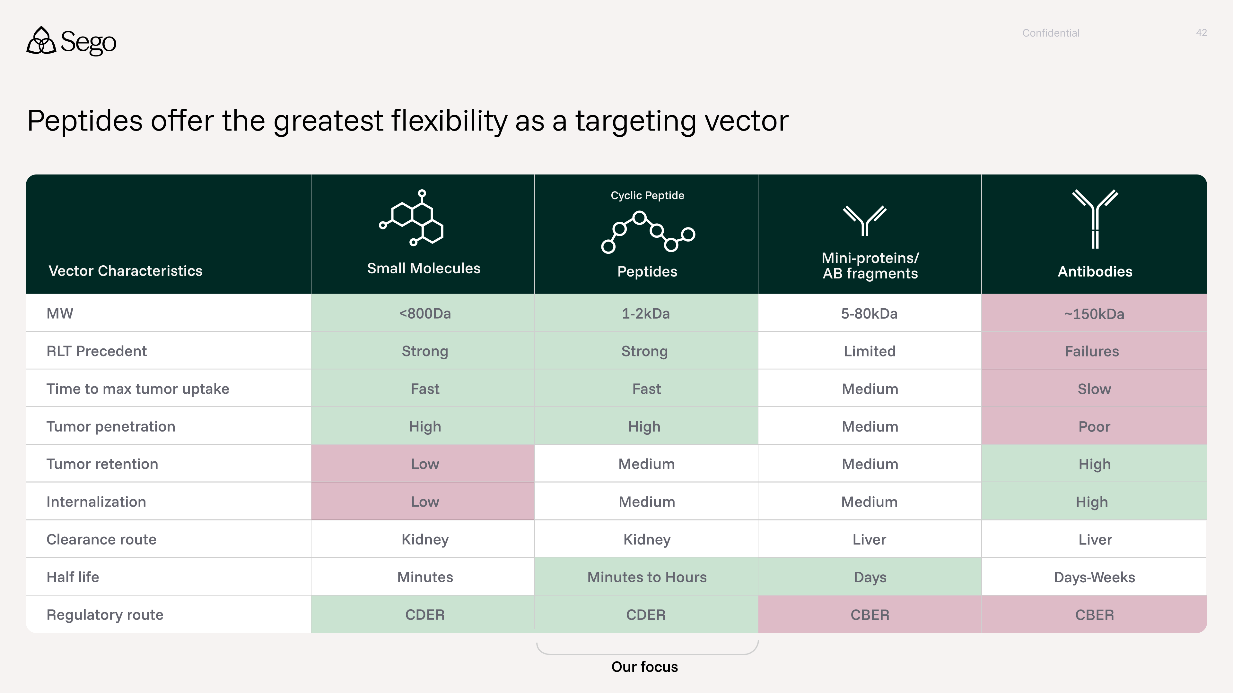

Please elaborate on the strategic rationale for selecting Tb-161 as the second isotope. What data package most strongly supports choosing Tb-161 as the follow-on isotope?

Tb-161 is an emerging next-generation radionuclide with characteristics similar to Lu-177 but offers superior tumor-killing, particularly for micrometastases, due to its additional high-energy Auger electron emission. The short-range Auger electrons deposit intense radiation directly into the DNA (upon internalization) or the cell membrane, and early clinical data suggest that Tb-161 can induce responses in patients who progressed after standard Lu-177 therapy (Liang, 2025, VIOLET Trial). The higher relative biological effectiveness (RBE) of Tb-161 has the potential to allow for reducing the administered activity while maintaining the same therapeutic effect. Its gamma emissions also enable SPECT imaging for dosimetry and patient management. Together, this data package supports Tb-161 as a differentiated next-generation isotope. Members of our founding team have been worked on auger therapies for over a decade. For example, Greg Mullen has developed and translated to humans ¹²³I‑ATT001, an iodine‑123–labelled PARP inhibitor.

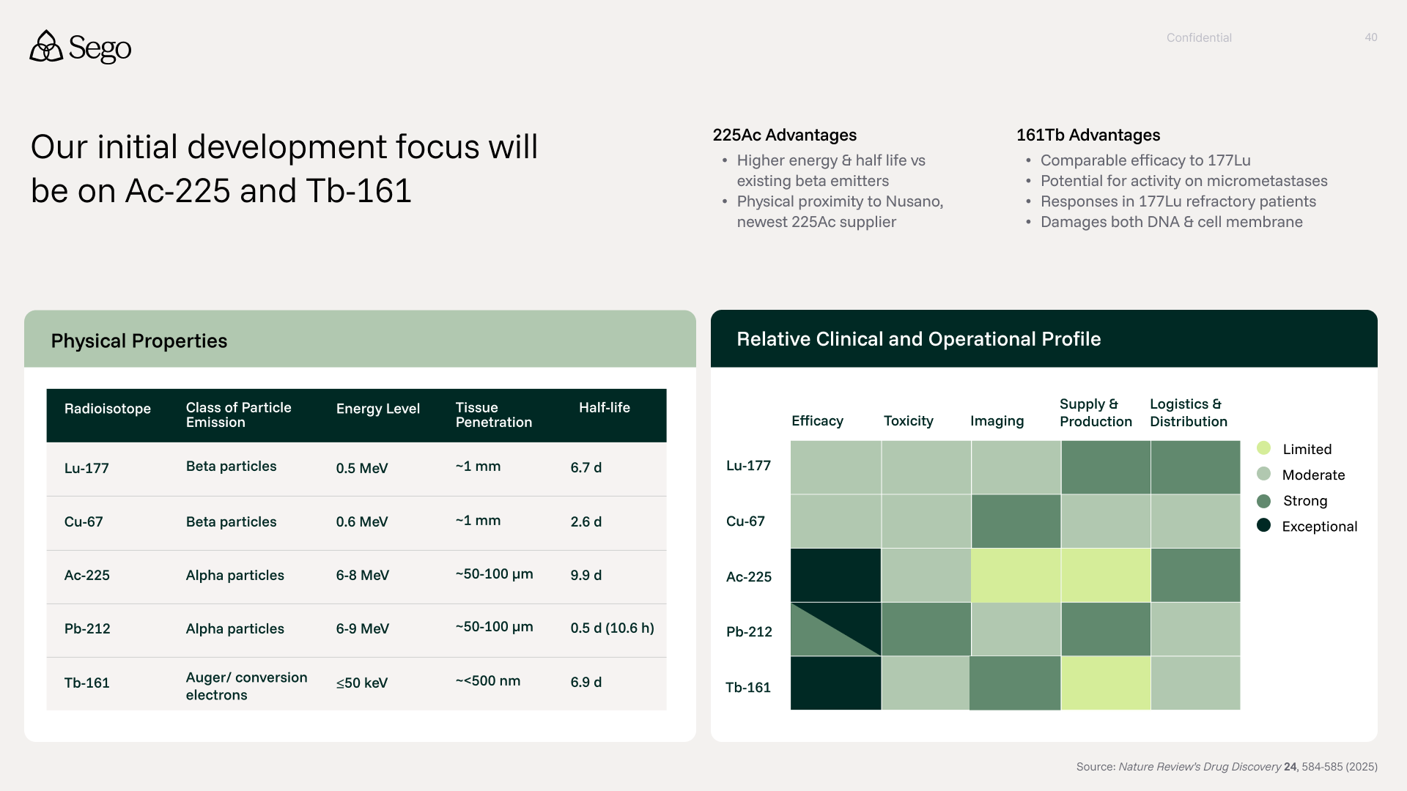

How did we evaluate CROs for externalized research?
We systematically evaluated multiple CROs against a Sego-defined RLT development workflow (as depicted below), assessing their capabilities across each stage from hit identification through cold and hot optimization, IND-enabling, and early clinical readiness. For each CRO, we scored technical capabilities, supporting infrastructure, and execution experience, alongside qualitative factors such as culture fit, risk, and inflection points for program advancement. This structured comparison enabled a transparent, side-by-side assessment of strengths, gaps, and cost models to inform CRO selection and partnering strategy.
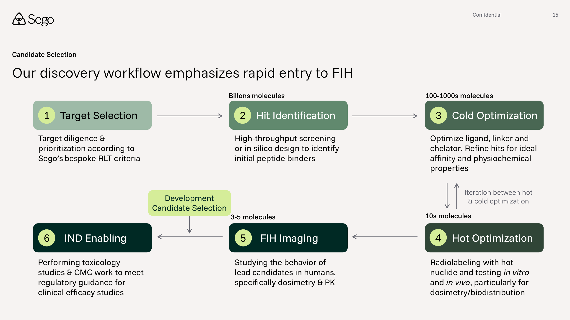

What CROs will we leverage for our externalized research (e.g. CRO1, CRO2)?
We have selected Wuxi as our first CRO for externalized research, with evaluation continuing to identify “CRO2” and additional CROs for different types of externalized work.
Wuxi was selected for multiple reasons, including: (1) their extensive capabilities across our discovery workflow, from peptide screening, through to in vivo radiation capabilities (2) they offer highly competitive pricing (3) members of our team have deep experience working with teams at Wuxi and high confidence in the quality of work produced.
Looking beyond Wuxi, we are evaluating an additional 4-5 CROs. Of these, 2 CROs may have end to end capabilities through partnerships with external organizations. 2-3 providers would only cover steps 2 and 3 of our workflow above - screening & cold optimization. Another provider would only be potentially utilized for hot work.
How will we make decisions about on- and off- ramping programs from different CROs?
Programs are advanced through our discovery workflow using defined stage gates with explicit on- and off-ramps at each stage transition, allowing us to evaluate progress and, if appropriate, transition work between CROs at predetermined inflection points. These transitions correspond to the stages in our workflow (Target Selection → Hit Identification → Cold Optimization → Hot Optimization → FIH Imaging → IND Enabling), with each gate tied to a specific technical data package and decision criteria. For example, hit quality and binder diversity following screening or SAR progression and PK characteristics after cold optimization.

These gates provide both objective go/no-go decisions for program advancement and clearly defined operational points where a program can move to the CRO best suited for the next type of work. For instance, a program may begin with a screening-focused CRO during Hit Identification, transition to a medicinal chemistry-focused CRO during Cold Optimization, and move to a specialized radiochemistry and in vivo radiation CRO for Hot Optimization and dosimetry studies. However, our intention is to use these off ramps sparingly.

By structuring CRO transitions around these defined stage gates, we ensure that any on- or off-ramping occurs only at natural program milestones with complete data packages, minimizing disruption while maintaining flexibility to optimize quality, speed, and risk management throughout the discovery process.

For a single pre-clinical program, how much will each block of work cost, e.g. by stage of development?
We anticipate spending roughly ~$2.6M per program split across the following phases of discovery: Hit Identification - $600K, Cold Optimization- $1M, Hot Optimization $500K, and IND Enablement (CMC, Tox) - $500K. This excludes spend on internal FTEs/payroll.
Hit identification spend would cover initial screening, likely peptide DEL or mRNA, and validation of these hits, as well as follow-on rescreening. Cold optimization is the most resource and compound intensive, where we anticipate synthesizing and testing in the 100s to 1000s of compounds by both biophysical and cellular biology approaches. Hot optimization will focus on murine dosimetry, some hot cell kill & internalization, as well as some radiolabeling optimization & stability testing, covering ~10s of molecules, thus is less resource intensive. Lastly, we are planning to support CMC needs for FIH & IND enablement, as well as GLP tox.
Note, FIH costs are described in the next question.
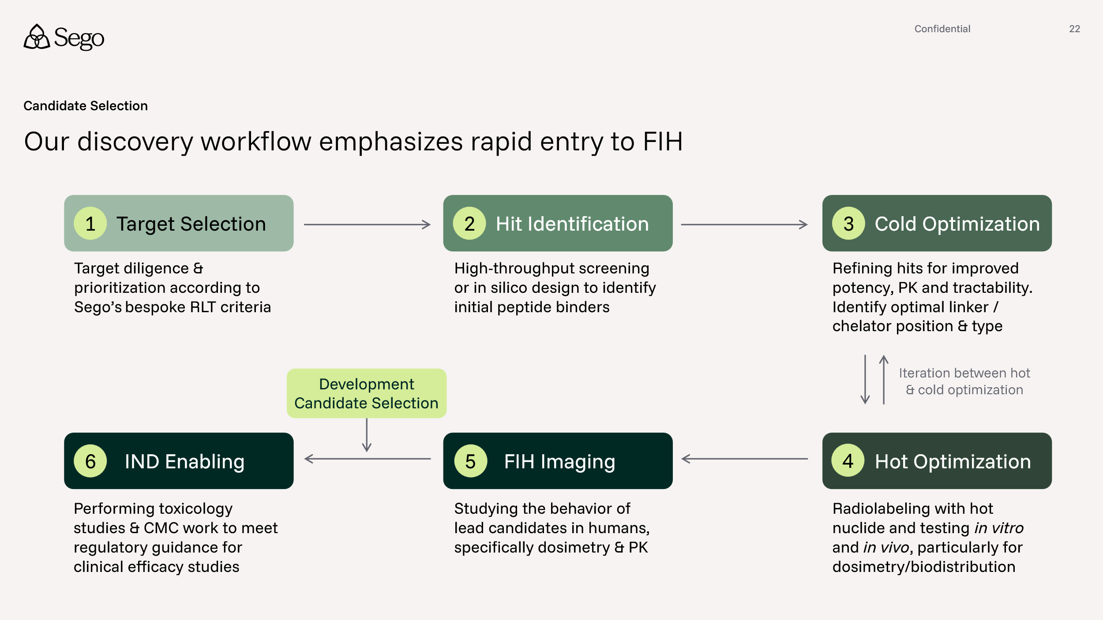

Clinical
For a single program, how much does each stage of clinical development cost?
The total development cost for a single program from FIH and into Phase 1 / 2 is roughly $20M total, with ~$2.4M for the FIH, and $18M in Phase 1 / 2. We would expect to spend this $20M for a single program over 2026-2030, with most of the Ph 1 /2 spend occurring in 2029 and 2030. The majority of these costs cover operation of the trial at cites & CMC, with smaller portions covering specialized consulting, fixed assets like Gallium generators at sites, software and more. This excludes spending on internal FTEs/payroll.
Are the typical IND enabling studies which meet US GLP/GMP standards required for FIH imaging studies?
There is a framework for this approach in the US using an exploratory IND (eIND) route, where you do not require non-cGMP precursor for manufacturing. However, the FDA eIND guidance for industry is silent on the requirements for a GLP tox study. We have opened an eIND and will request a Type C meeting with FDA where we will provide justification as to why we do not require GLP tox study to support a Phase 0 FIH imaging study and ask the agency if they agree. At the same time, we will get feedback on the Master Clinical Protocol.
More broadly, our strategy for FIH imaging studies is listed below with the appropriate competent authority legislation.
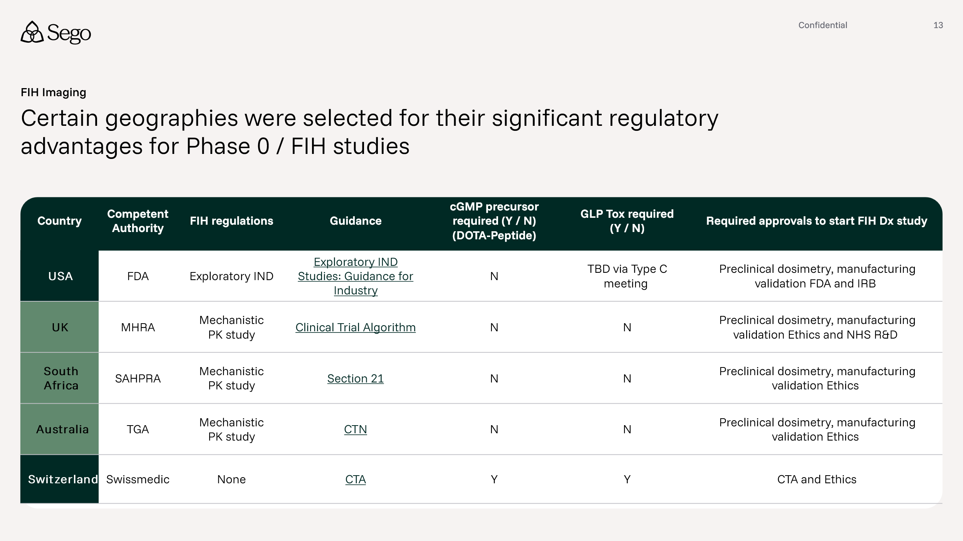
Where will we conduct our clinical work?
The initial sites are depicted below.
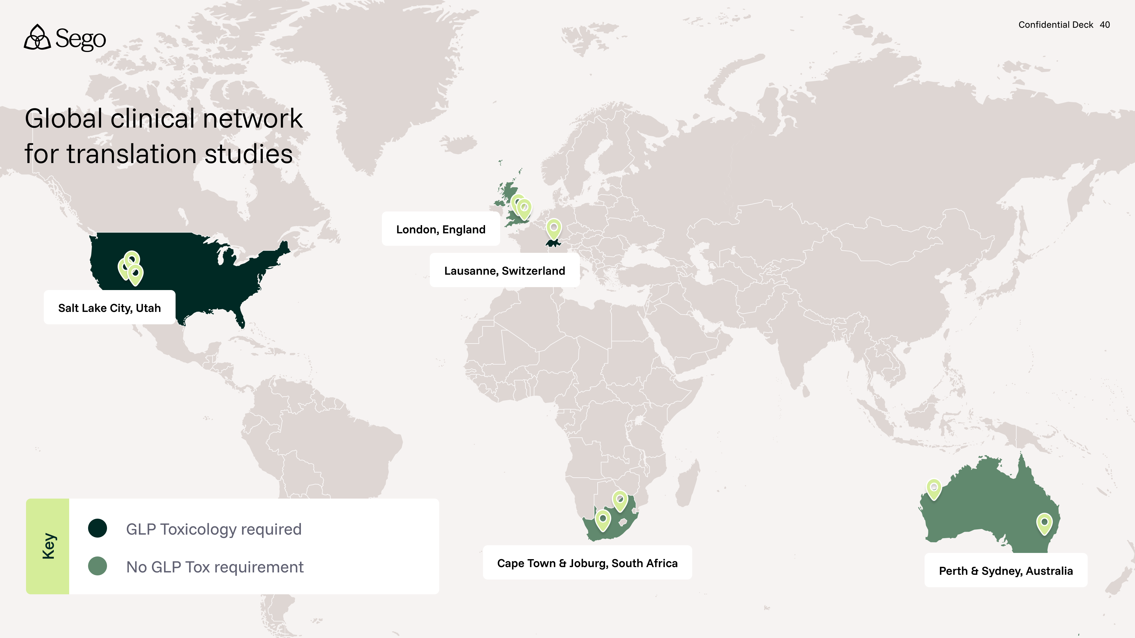

What parameters did we use for site selection?
The initial selection criteria are:
- The PI has previous experience in conducting Phase 0/FIH and Phase 1 diagnostic and therapeutic imaging studies
  - The Sego founders have run studies directly with the PI previously and have experience of high performance
- Established local manufacturing / radiopharmacy of PET and SPECT diagnostic doses and potential to manufacture therapeutic RLT doses
- Clinical Trials Unit familiar with RLT studies
- The site routinely provides performs clinical PET, SPECT and RLT therapy dosing
We are currently in discussion with the sites to establish a Master Clinical Trial Agreement and will conduct a formal feasibility exercise prior to signing the agreement.
Why aren't we using Germany as a clinical site?
We are not leveraging Germany because the regulatory pathways available for early, exploratory clinical work do not allow for standardized, highly rigorous, prospectively defined protocols that generate reproducible comparative data.
While we have prior experience working with KOLs under §13(2b) AMG and AMRadV, this framework is designed for physician-led individual treatment use — similar to named patient or compassionate use — rather than structured clinical investigation. These evaluations do not require a formal protocol, predefined inclusion/exclusion criteria, prospectively defined endpoints, or controlled study design. As a result, they are not suitable for our objective: a methodical, PK- and imaging dosimetry-driven comparison of multiple compounds against the same target to enable data-driven lead selection.
A formal prospective Ph 1 imaging study in Germany is technically possible; however, it would fall under BfArM oversight. BfArM is widely regarded as slow in approving radiopharma studies, introducing meaningful timeline risk to the development plan.
What specific capabilities are you building out in CMC Stage 1? What are we building out in CMC Stage 2?
Stage 1 will be built to supply early clinical studies (up to Ph 2) with Stage 2 bringing significantly expanded capabilities and the ability to supply Ph 3 and commercially. See slide for details.
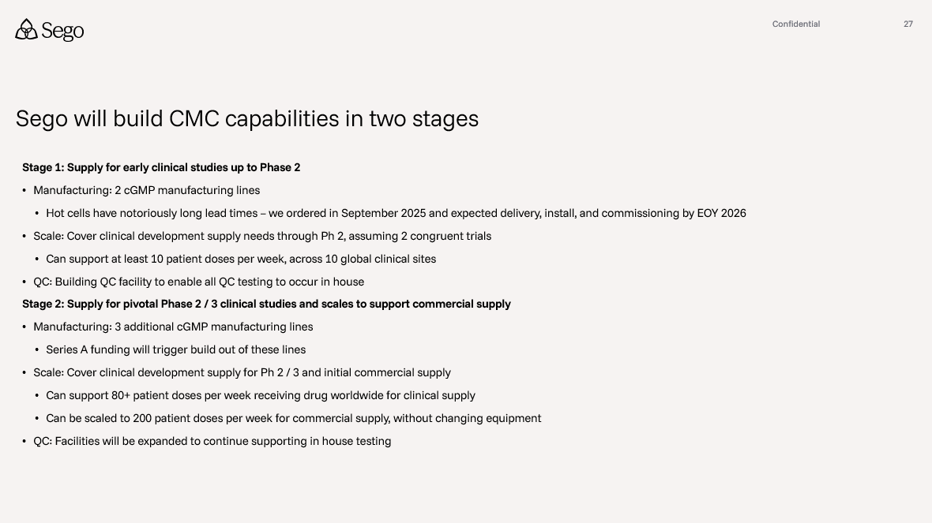
Will we do all the CMC for Ph 0 at our clinical sites? Are they prepared for this volume?
Yes — our selected sites have full in-house CMC capabilities for both diagnostic and therapeutic RLT dose manufacturing, covering routine clinical production alongside trial supply. For US sites, Sego will produce all diagnostic and therapeutic doses from its own facility.
To ensure no single site is overburdened, Phase 0 trials will run across a minimum of three sites simultaneously. Given the relatively small patient numbers involved in Phase 0, we anticipate a manageable throughput of approximately one patient per week per site — a volume well within the operational capacity of our selected centres.
Are we planning to have FIH data from two molecules by the Series A?
Yes, we are planning and budgeting to have data from two FIH studies for the Series A in mid-2028. The current budget and plan have one study completed mid-2028, and a second study with interim data mid-2028 and completing end of 2028.

Can RLT be combined with other drugs?
Yes, and RLT is particularly well-suited to combination approaches. Because RLT drives its toxicity profile through organs at risk — rather than the systemic mechanisms that drive most conventional oncology drugs — it has minimal overlapping toxicity with the majority of therapeutic classes, including IO agents, ADCs, BiTEs, and TKIs.
Even with chemotherapy, which has a broader toxicity profile, overlapping adverse events are not a given and depend on the specific regimen. Where some overlap does exist, RLT can typically be sequenced after chemotherapy, administered between cycles, or introduced during drug holidays — preserving the benefit of both modalities without compounding tolerability challenges.
This favorable toxicity profile makes RLT a practical combination partner across much of the oncology treatment landscape, and opens meaningful opportunities for rational combination strategies that would be difficult to execute with less well-tolerated therapeutic modalities.
How do you imagine positioning ACP3 among all the other therapies available in prostate cancer? Do you imagine it would ever be used in combination with Pluvicto?

RLT is a highly combinable modality, but we believe ACP3-RLT has the target characteristics to displace Pluvicto. Driven by ACP3's broad and highly specific expression profile in prostate cancer, our intent is to go head-to-head against Pluvicto in mCRPC. We believe we can demonstrate significantly superior efficacy with a better safety profile. Specifically salivary gland toxicity, currently dose limiting, can be eradicated.

Into the future, we aim to develop ACP3-RLT in first-line therapy with curative intent. RLT holds a clear biological advantage over external beam radiotherapy (EBRT) in this setting: while EBRT targets the primary site, RLT has the potential to address circulating cancer stem cells and micrometastases simultaneously. We must first demonstrate a monotherapy safety and efficacy profile to satisfy patients, referring physicians, and regulators alike.

ACP3-RLT's favorable toxicity profile opens the door to combination strategies with multiple modalities. We anticipate exploring combinations with hormone therapy, PARPi, and biologics as early as Phase 1b/2 expansion cohorts, given the limited overlap in toxicity profiles. Combinations with chemotherapy will require a more deliberate approach to sequencing and scheduling to avoid compounding toxicity risks and will be evaluated accordingly.

How much would running 3-4 molecules against a single target into Ph0 change timelines and cost compared to running only a single molecule? What features in the Ph0 study would you examine before nominating a Ph1 candidate? What tox/IND studies need to be run before vs after this process?

Our aim is to run 3–5 candidates through Phase 0 costs at an additional cost of 30% vs 1 candidate. This also adds approximately 3 months compared to a single candidate program. This is a modest premium that dramatically improves the probability of selecting a winning asset before major capital is deployed.

Translating multiple candidates into humans simultaneously using quantitative imaging PK and dosimetry, provides the data needed to select the molecule with the widest therapeutic index and the highest probability of clinical and commercial success. This provides a go/no go on the molecule and target before GMP manufacturing scale-up, full IND-enabling toxicology, and Phase 1 operational costs are incurred.
In the study we will be looking to ensure we can deliver the following dosimetric values with our Ph1 program.
- Tumor absorbed dose (efficacy): >80Gy cumulative, ideally 100Gy
- Kidney: ≤23 Gy (safety) cumulative (established EBRT dose limit)
- Red marrow: ≤2 Gy cumulative (hematologic toxicity guardrail)

These thresholds use external beam radiation therapy (EBRT) tolerance limits as validated guardrails, providing a clinically defensible and regulatory-familiar framework. Critically, Ph0 will also flag any unexpected off-target organ exposure not observed in preclinical models.

The regulatory classification of Phase 0 is as a microdosing/mechanistic study, not a clinical safety or efficacy study. This creates a highly capital-efficient entry point, although the competent authorities view differs by county.
  - South Africa and Australia: Phase 0 is classified as a mechanistic microdosing study (<100 µg cold mass). Competent authorities do not require GLP toxicology studies. Well-characterized, non-cGMP precursor meeting the same specifications as cGMP material is acceptable. Mouse dosimetry data generated on the same precursor batch intended for human use serves as the preclinical safety package.
  - United States: The program operates under an exploratory IND (eIND), which is purpose-built for imaging PK-based candidate screening. Sego has opened an eIND and is requesting a Type C meeting with FDA to confirm, (i) non-cGMP precursor is acceptable at this stage, (ii) no GLP tox study is required pre-Phase 0, and (iii) the Phase 0 trial design is agreed upon. This meeting de-risks the regulatory path before committing further capital.
Once a lead candidate is selected from the Ph0 data, the regulatory and manufacturing requirements step up appropriately prior to Ph1 commencement, (i) cGMP-manufactured precursor is required for all subsequent human use and (ii) single acute GLP toxicology study in a single rodent species must be completed. This staged approach is the core capital efficiency argument for the Phase 0 design.
Alternative dosing schedules - e.g., fractionated, BCR-driven - have started to generate compelling data in RLT. Have you contemplated exploring any of these strategies across your current pipeline? Would that choice be target or indication driven?
Yes, these have been thoroughly discussed as a team and with PIs. There is an opportunity for RLT to become a back-bone therapy through the patients’ journey provided organ at risk doses are not cumulatively exceeded. The choice is biomarker and indication-driven rather than purely schedule-driven. We view fractionated, BCR-triggered, and MRD-triggered approaches as fundamentally patient-selection strategies that manifest as schedule variations; the strategic decision is which biomarker-defined population to treat and when. Across the pipeline this unlocks earlier-line and curative-intent positioning for each asset, since in earlier disease states, biomarker-defined populations may not be identified by conventional imaging-based selection alone.
Indication-specific examples across the pipeline:
Prostate (ACP3-RLT): BCR-triggered intervention in patients who have failed primary therapy but are not yet overtly metastatic. Predominantly nodal recurrence with preserved visceral function creates a clean therapeutic window where ACP3’s wide TI supports higher per-cycle activity than tolerable in heavily pre-treated mCRPC. Payload favors a beta + Auger/alpha mix (161Tb or 225Ac) to address nodal micrometastases and dormant cells.
Colorectal and other GI (MRD-driven): ctDNA-defined MRD positivity selects patient’s post-resection or post-chemotherapy who are radiographically negative but biologically active. Sub-clinical micrometastases and CTCs are the disease burden; payload economics favor short-range Auger and alpha emissions where beta crossfire is wasted.
Dosing schedule modulation: The original 6-cycle, fixed-interval VISION schedule reflected regulatory pragmatism rather than biological optimization. Fractionated, de-escalated, or extended-interval schedules are deployed as a tactical lever once the biomarker-defined population is fixed and used to optimize the therapeutic index for a given indication and payload combination, not as the primary patient-selection strategy.
How do you plan to leverage dosimetry data for patient inclusion (e.g., we have seen difference between SUVmean vs SUVmax, uptake > liver, minimum SUV, etc).
Sego will use the imaging companion diagnostic prior to RLT therapy to drive individualized dosimetry-based patient selection. Our patient inclusion framework combines three layers of quantitative screening:
First, qualifying lesion uptake on the diagnostic imaging companion: a per-patient threshold of tumor uptake greater than a reference normal organ (typically liver, analogous to the Krenning score or VISION criterion for PSMA-PET) to confirm sufficient on-target expression across the dominant disease burden. We pair SUVmax (peak lesion intensity) and SUVmean (whole-tumor expression homogeneity), with a SUVmin floor on index lesions to exclude patients with insufficient receptor density to deliver a tumoricidal dose. SUVmean is the more clinically meaningful predictor of absorbed dose because it reflects average dose delivered across the lesion volume, whereas SUVmax can over-represent receptor “hot spots” that don’t translate to whole-tumor kill; a position recently validated by the ENZA-p sub-study, where pre-specified SUVmean-based enrollment rules translated into encouraging and potentially practice-changing survival outcomes.
Second, an individualized predicted absorbed dose threshold derived from the Phase 0 imaging PK/dosimetry study: only patients with a predicted cumulative tumor dose of >100 Gy and predicted critical-organ exposure within tolerance (kidney ≤23 Gy, red marrow ≤2 Gy) proceed to therapeutic dosing. This is calculated net of prior EBRT and prior RLT exposure where relevant, accounting for tissue sensitivity and recovery time. The framework converts qualitative “target-positive” eligibility into a per-patient quantitative go/no-go.
Third, exclusion of patients with discordant or off-target uptake patterns that would predict unfavorable therapeutic index at the individual level — i.e., the population-level asset thresholds (tumor-to-kidney >3, tumor-to-red marrow >20) become per-patient verification criteria using their own imaging dosimetry.
Why this matters for the program: dosimetry-based patient selection is one of the most actively debated areas in nuclear oncology today, and the FDA’s August 2025 draft guidance is moving the field decisively in this direction. Current OAR tolerance thresholds are inherited from external-beam radiotherapy, but RLT radiobiology is fundamentally different (continuous low-dose-rate exposure vs. fractionated high-dose-rate), so a methodological gap remains — which Sego views as both a challenge and an opportunity to help set the standard. Our asset-level dosimetry thresholds are informed by approved RLT products and EBRT critical-organ limits, with Lutathera’s on-target marrow irradiation and Pluvicto’s crossfire-plus-blood-pool marrow dose as the benchmark failure modes which we engineer against. Our first six targets have no known red marrow expression, and med-chem optimization drives rapid tumor uptake and retention with fast blood-pool clearance, further widening the therapeutic window. Sego envisages a rapid evolution toward a benefit-risk profile compelling enough to enable transition into earlier disease states, supported by the FDA’s Frontrunner initiative.
The Phase 0 imaging dosimetry is therefore doing double duty: screening multiple candidates for asset advancement while simultaneously establishing the per-patient inclusion thresholds that will govern the pivotal trial population — selecting both the best candidate and the right patients before significant capital is deployed.
How do you plan to approach enrollment of patients who have received prior RLT?
Sego will include prior-RLT patients rather than exclude them, this is both a clinical and a commercial need. An example indication would be in the post-Pluvicto mCRPC relapse setting, where there is no established standard of care. This is in line with other trials which have been presented to the FDA, such as Novartis 225Ac-PSMA-617 programs which allow prior RLT (Pluvicto) exposure.
Inclusion is governed by a cumulative dose accounting framework: critical-organ tolerance limits, currently based on EBRT limits and may change in the future based on long term follow up safety data based on RLT exposure, (kidney ≤23 Gy, marrow ≤2 Gy, salivary glands ≤26 Gy) are cumulative, so the residual dose budget for the new therapy equals OAR tolerance minus dose already delivered. For Pluvicto-experienced patients, prior cumulative OAR dose is established either from on-treatment dosimetry records or, where incomplete, from conservative population-mean absorbed-dose models per cycle of 177Lu-PSMA-617. The patient’s pre-therapy Phase 0 imaging, for example, with an ACP3 agent, then predicts incremental dose per GBq, and prescribed activity is capped to stay within remaining tolerance.
In practice, the trial design includes: (1) explicit cumulative-dose inclusion thresholds with headroom for therapeutic intent (e.g., prior kidney <15 Gy, marrow <1.3 Gy); (2) stratification of RLT-naïve vs RLT-experienced cohorts so efficacy and safety read out independently; and (3) individualized per-cycle activity or cycle number for prior-RLT patients, governed by patient-specific dosimetry. For example, because ACP3 is a different target from PSMA, the only meaningful overlap is at OARs, predominantly kidney.
How are you thinking about the theranostic pairing strategy across your pipeline?
Sego’s theranostic pairing strategy is to co-develop a matched imaging diagnostic. The imaging Dx development will be integrated into therapy development from first-in-human onward and patient selection driven by quantitative biomarkers; primarily the imaging companion diagnostic, supplemented where indication-relevant by blood biomarkers such as MRD. The specific pairing (e.g., biomarker stack, threshold criteria) is tailored per indication.
Sego is advancing diagnostic solutions to leverage dual revenue opportunities; nonetheless, our primary commercial focus remains on therapeutic development.
Trial design is the strategic enabler here: when structured correctly, the imaging Dx data generated during therapy development supports a single regulatory filing that secures both indications on the label, the companion diagnostic for therapy patient selection and the standalone diagnostic for broader cancer staging indications. This increases the asset value per program at marginal incremental development cost.
The team has direct execution experience across the full theranostic value chain — clinical development, FDA approval, and commercialization of imaging diagnostics, including partnering distribution agreements with radiopharmacy networks which materially de-risks the dual-track regulatory and commercial strategy.
Where does the opportunity for combo therapy fit within your clinical development sequencing?
RLT is an orthogonal, physics-based MOA particularly well-suited to combination approaches. RLT drives its toxicity profile through organs at risk, rather than the systemic mechanisms that drive most conventional oncology drugs, it has minimal overlapping toxicity with the majority of therapeutic classes, including IO agents, ADCs, BiTEs, and TKIs.
Even with chemotherapy, which has a broader toxicity profile, overlapping adverse events are not a certainty and depend on the specific regimen. Where some overlap does exist, RLT can typically be sequenced after chemotherapy, administered between cycles, or introduced during drug holidays, preserving the benefit of both modalities without compounding tolerability challenges. Chemo-radiation is a SoC in many cancers treated with external beam radiation.
This favorable toxicity profile makes RLT a practical combination partner across much of the oncology treatment landscape and opens meaningful opportunities for rational combination strategies that would be difficult to execute with less well-tolerated therapeutic modalities.

CMC:

Can you explain the phased build out of the facility in greater detail? What will the capabilities be for each phase and how much would building the facility cost?

The building is roughly 65000 sq. ft. and is being built in 3 stages. The facility build costs are supported partly through a Tennant Improvement allowance included in the lease agreement.

Current build: Stage I-A (~$15M, completion December 2026)
- 4800 sq. ft. chemistry, biology, and supporting labs for discovery and development of our targeted peptide ligands and targets
- 2700 sq. ft. radiochemistry labs for further development and validation of our advancing RLT candidates for in vitro and in vivo preclinical testing. Also equipped for validation and translation of our mature candidates to clinical studies.
- 3100 sq. ft. vivarium equipped for RLT related imaging, biodistribution, pharmacokinetics, and small scale acute GLP toxicity studies
- 2350 sq. ft. GMP suite including manufacturing and quality control testing rooms for support of FIH, Phase I and early Phase II studies.
- 11000 sq. ft. office / common area

Series A gated: Stage I-B (Start 2028, Completion 2029)
- 4000 sq. ft. of additional R&D expansion for toxic chemistry, molecular biology, tissue culture, and automation labs.
Gated on Ph1 therapy data read out gated: Stage II
- 6000 sq. ft. of GMP space for 3 production lines for Phase II-III and commercial manufacturing of advancing RLT candidates.
- 1550 sq. ft of additional QC and process development space to support the in-house validation and release testing.
- 7300 sq. ft of support space including receiving, packaging, shipping, and waste storage and handling.
- 6000 sq. ft additional office & common space
Gated on +ve Ph2 data read out gated: Stage III
  - 7000 sq. ft. of additional GMP space including 4 more production lines for commercial manufacturing.
Estimated cost to build out Stage I-B, II & III : ~$25M
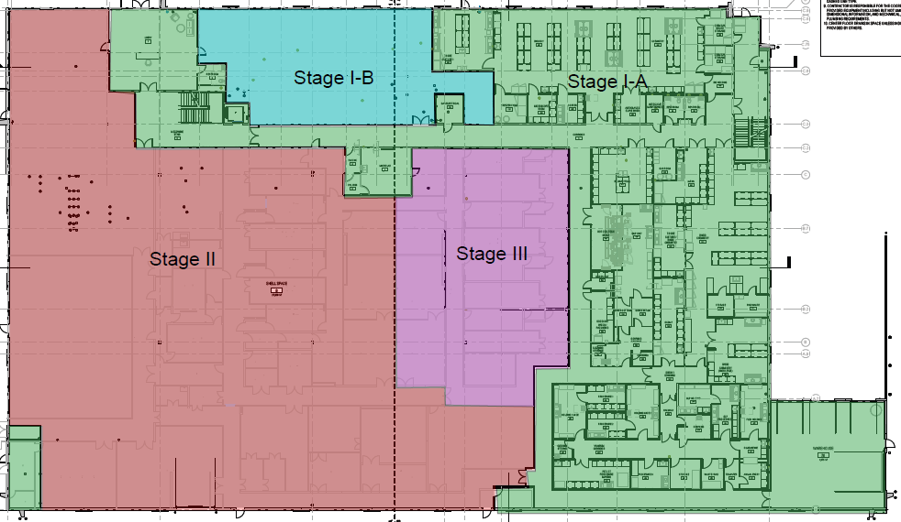
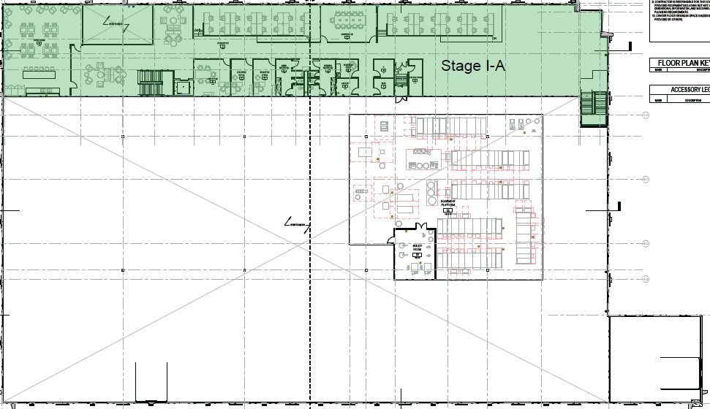

Which aspects of the RLT CMC process will become commoditized and which will remain difficult over the next 3, 5 and 10 years?
In 3 years, we do not believe any part of the value chain will be commoditized. At this point we will be starting our Ph1 therapy studies. Through the team’s deep domain expertise, Sego is building its CMC capabilities in 12 months. Typically, this can take RLT companies 36 months based on benchmarking. The strategic importance to the organization of having R&D adjacent to CMC will reduce time to clinic on a complex platform. The commercial case of having CMC capabilities has shown to add value (slide below).
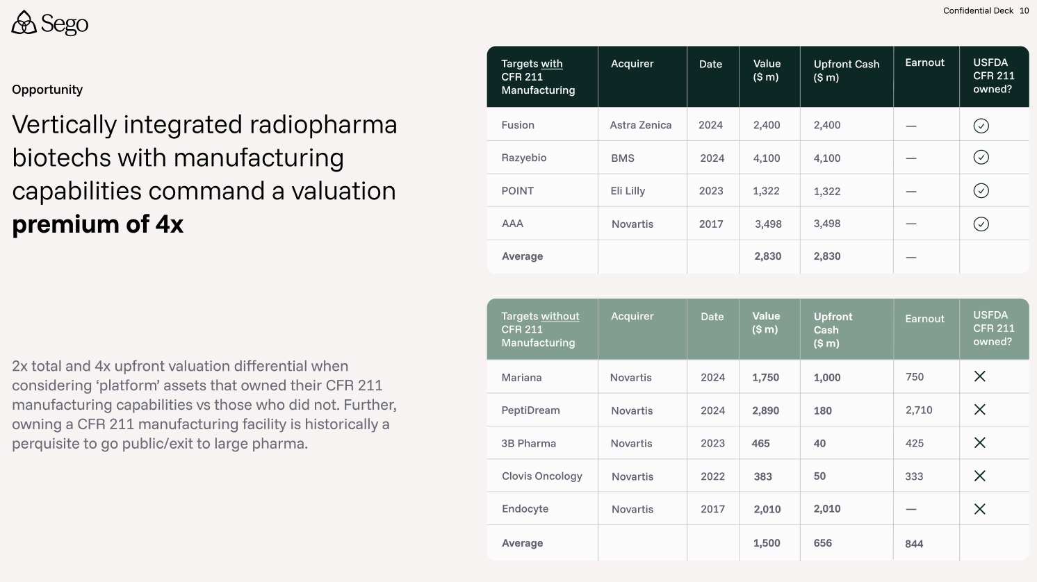
In the 5-year horizon durable differentiation remains at the interface of peptide ligand discovery, alpha-emitter radiochemistry, high specific activity for ultra clean targets, and translational GMP manufacturing. This will remain complex and will require close interaction between pre-clinical and clinical teams.
We do believe that routine manufacturing for generic products (Lutathera) can be commoditized, however, at scale manufacturing will deliver lower COGs. Adjacency to isotope source allows for further reduction of COGs and security of supply chain. QC workflows are an area where we believe standardization will be maximal and may lead to a tail wind of faster release times for product.
Over the next decade, we believe higher automation will occur in the field leading to potential for commoditization, but the reliance on just in time supply chain, mixed with the challenges of radioactive production mean deep domain expertise will still be required, i.e personnel with the relevant domain expertise will not be commoditized.
What regulatory approvals do you need regarding your facility?
Following licenses are needed to open the facility in the State of Utah. Most of these will require the facility to be in place at the point of application.
- RAM (radioactive) License (State of Utah- Dept of Env. Qual.) - application completed Q4 2025, expecting issue Q4 2026
- State of Utah – Pharmaceutical Manufacturer Class C license (Board of Pharmacy)
- Liquor License – Ethanol cost of use – State of Utah requirement
- State Issued - Controlled substances for use of precursor materials

What does your radioisotope supply chain (and your suppliers supply chain) look like? Where are there vulnerabilities in this supply chain?
We have a strategy developed for short-term (R&D/Clinical Trial needs) and long-term (commercial needs) supply chain.
Our strategic relationship with Nusano, the isotope supplier adjacent to our facility, strengthens this model by providing secure access to Ac-225 and Tb-161, enabling shorter development cycles compared with programs dependent on constrained market supply.
With respect to contracting, we are at various levels of discussions with each of the following:
 | Supplier | Location | R&D | cGMP | Notes
Ac-225 | Eckert & Ziegler | Germany | Y | Y | R&D availability is sufficient but GMP grade for commercial use still ramping up. Will increase in maturity with our clinical development timeline.  Strategic relationship with Nusano in Utah minimizes logistics in acquiring isotope.  Seeking suppliers with production methods that remove or eliminate  Ac-227 impurities
 | Actineer / ITM Isotope Technologies | Germany / Canada | Y | Y
 | TerraPower Isotopes | USA | Y | N
 | PanTera (EU) | EU | Y | N
 | Nusano  (online in 2027) | USA (Salt Lake) | Y | Y
 | NorthStar Medical Radioisotopes | USA | Y | N
Tb-161 | TerThera B.V. | Netherlands | Y | Y | Emerging isotope with limited availability. Isotope productions especially GMP grade are expected to grow over the next 2 years and should expand congruently with our clinical development.
 | ITM Isotope Technologies Munich | Germany | Y | Y
 | Isotopia Molecular Imaging | Israel | N | Y
Lu-177 | Shine Technologies | US | Y | Y | Lu-177 (n.c.a) quality isotope available commercially with multiple productions per week with some suppliers. Supply chain with highest maturity in comparison to other isotopes
 | Eckert & Ziegler | Germany | Y | Y
 | Isotopia | Israel  US | Y | Y
 | ITM | Germany | Y | Y
Ga-68 | Eckert & Ziegler | Germany / US | Y | Y | Research / Commercial Grade generators available. 3-month lead time.
 | IRE / Cardinal Health | Belgium  US | Y | Y
 | ITM | Germany | Y | Y | Not available commercial in the USA.

BD/Strategy
The use of AI mentioned in the last slide - From our previous conversations, We think that primarily refers to using AI approaches for image processing/interpretation of the clinical data— is that correct? (Not that you wouldn’t use AI tools for peptide discovery- but that probably isn’t as high impact as interpretation of the imaging data.)
Correct – we will leverage existing and novel AI / ML for imaging processing, interpretation and most importantly, dosimetric analysis. Dosimetry is a critical component of our clinical development strategy. In our Phase 0 first in human imaging trials, we will deploy commercially available, validated dosimetry software platforms that process serial imaging data collected at multiple timepoints to generate time–activity curves. These curves measure how the radiopharmaceutical is retained by the target and clears across tissues over time. This then calculates a precise, quantitative picture of where the therapeutic payload is delivered at voxel level, effectively the radiation dose.
This data serves two strategic functions, (i) it enables real-time dose optimization during early-phase studies, and (ii) it generates the quantitative evidence base required for FDA regulatory submissions. Importantly, this includes the justification of Phase 1 therapy starting dose and characterization of dose–response and dose–toxicity relationships. Our approach is fully aligned with the FDA's 2025 draft guidance on dosimetry-driven development of therapeutic oncology radiopharmaceuticals, which explicitly mandates prospective dose optimization as a development standard.
Operationally, we are ahead of the curve on deploying AI to streamline routine workflows across the organization, from legal to accounting. We are already saving SG&A dollars based on our forecasts.
In research, we continue to evaluate progress in AI-driven discovery areas such as peptide discovery and medicinal chemistry, though our current view is that deploying AI / ML will not add value for targets 1-6. We have engaged with 5+ vendors with models and whilst they might be able to help with start points for screens, and narrow down a list of potential binders, they cannot handle whole molecule. All known models for drug design are built around the top 3 rows of the periodic table and RLT contains lanthanides and actinides. We will keep close to progress in the field. Further, our local SLC talent are AI / ML native, and this is already adding tremendous value.

You had mentioned in earlier conversations that external groups were reaching to see if your team could run their clinical develop program for RLTs; is that something you are actively considering (ie, bringing in outside molecules)? It might de-risk timeline concerns on peptide discovery activities; on the other hand, it might be single assets rather than a basket of potential candidates. Just wondering if this is a significant part of the evolving strategic plan or more of an opportunistic “this is something we might do if a compelling molecule/collaboration opportunity came up”
We would in license if an asset (i) fits within our target selection criteria, and (ii) if a basket of potential candidates for translation were available. Our primary focus is advancing the six targets selected after deep diligence by the Sego team. These six internal programs represent the core of our development strategy and were chosen based on our experience in the field and strong biological rationale. As a result, most of the team’s effort and resources are directed toward executing on these programs as efficiently as possible.
However, because of our deep network in the radiopharmaceutical community, we have been approached with opportunities for licensing and partnerships. These have come at the preclinical and early translation stage, with the goal of Sego taking on (i) translation of the molecules to the clinic, or (ii) collection of non-China clinical data. We would actively pursue these opportunities in close alignment with the Sego board.
To keep the R&D team focused on the internal asserts, a small BD project team conducts a defined diligence process, based on the following criteria,
- Strength of the target, per our internal target selection criteria: We approach this by ranking against our selected targets. This is conducted with the same rigor, using the criteria & qualitative scoring approach for the selection of internal programs.
- Availability of a basket of potential candidate molecules: As with our internal programs, we intend to advance multiple candidate molecules into FIH studies from an in-licensed asset. Thus, we are prioritizing external assets where there is a basket of candidate molecules available either through structure reactivity relationships and / or number of potential binders have been identified from a screening platform.
- Competitiveness & quality of the data package, commercial attractiveness and FTO: We approach this by trying to understand the totality of data collected around the asset. We are specifically seeking evidence of established in vitro SAR, clear tumor uptake and retention, and a lack of retention in any organs at risk. In the ideal case, Phase 0 FIH data is available that meets our criteria for absorbed dose the tumor vs absorbed dose to organ ratio. We evaluate the competitive landscape (RLT or otherwise) in the given indication. A key criterion is whether the IP portfolio for the asset is defensible and if FTO has been established.
- Attractiveness of the deal: The reputation of the partnering team and prior track record of success is important. Overall, we assess the likelihood of coming to mutually agreeable terms. We are looking for deals that are heavily backloaded with smaller upfront payments.
- Strategic impact on our pipeline: We evaluate how taking on an asset will impact our ability execute on other priorities in great detail. We ask whether it will have a greater likelihood of delivering benefit to patients vs. any internal programs that might be impacted.
As of the time of writing, we have yet to identify an asset that meets the above criteria; instead we have declined to move forward with several conversations. There are four primary reasons we have declined to proceed: (i) low Sego priority target, (ii) lack of a diverse basket of compounds i.e. single asset (iii) narrow therapeutic index based on human data, and importantly, (iv) lack of FTO.
Most in-license opportunities to date have come from either Chinese biotechs or European academic centers. Chinese RLT biotechs cite the experience of the founding team, vertical integration in the US and global clinical development network as key reasons for wanting to partner. The European academics are generally teams we have known for over a decade and are intimately aware of our track record in this space. Going forward, a small, select Sego team will continue to evaluate licensing opportunities with these groups, while preserving the focus of the R&D team on internal programs.
Can you break down your use of proceeds by program, by year and for the facility build?
$63M will fund us until Series A including the following activities: the initiation & prosecution of 6 internal discovery programs, 2 FIH studies stemming from the 6 programs, buildout of the Salt Lake headquarters, and recruitment of a world class team.

Below is the spend as presented in the use of proceeds slides:
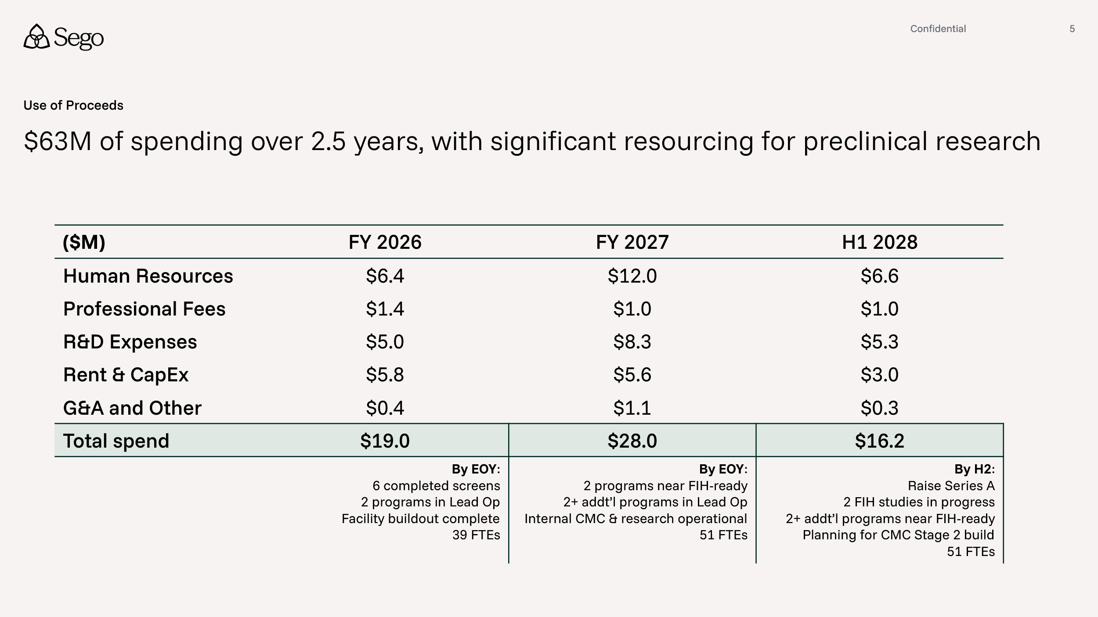
~$18M in R&D spend will support preclinical discovery efforts for 6 programs and IND enabling efforts for 2 programs. FIH work is budgeted for 2 programs, and is generally captured by professional fees & headcount above. The ~$19M above in Rent & CapEx supports the build out of the site (Stage I-A, $15M) and ongoing rent commitments and equipment leases.

Can you give an update on your fund raising process? Have you made any back up plans for a smaller round?
We are actively engaged in deep diligence with a focused, reputable group of investors, with a target close date in Q2. Given the significant interest & traction thus far in our process, we are not planning to downsize the round. The round is sized to fund multiple programs through meaningful human data readouts, which we view as the most value-creating inflection points for the company. Investors engaged in deep diligence are from funds with the capability to fund us through multiple stages and who share the belief that capitalizing us through early human data is key for the Series A.

How has the money in thus far been structured? Can you share the termsheet?
$20m equity has come in at priced round. The investment was at a $20m pre-money valuation, based on a seed round of up to $80m. The term sheet has been superseded by the funding agreement (SPA). The agreement is based on NVCA Model Legal Documents and available as part of final diligence.

